To help promote the event We’ve created a wordcloud of conference abstracts, in R!

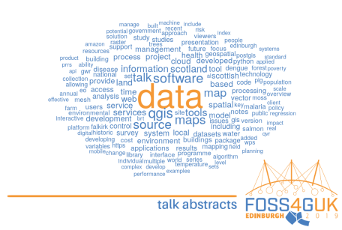

The conference is taking place in Edinburgh, Scotland at Dynamic Earth. It’s focused on free and open source software for geospatial (FOSS4G), as such is full stack. Everything from backend databases, ETL, analysis to web publication. Tools featured include QGIS, R, Python, PostGIS, leaflet and many others.

R script below.

﻿

library(tidyverse)

library(tidytext)

library(wordcloud)

# ----------------------------

data("stop_words")

f = list.files("~/dir/dir")

abstracts = lapply(f, function(i){

read_table(paste0("~/dir/dir/", i),

col_names = F) %>%

gather(key, word) %>%

select(-key) %>%

add_column(author = str_remove(i, ".txt")) %>%

unnest_tokens(word, word) %>%

anti_join(stop_words)

})

abstracts = do.call("rbind.data.frame", abstracts)

png("~/dir/dir/abstract_wordcloud.png",

width=1200, height=800, res=150)

par(mar = rep(0, 4))

abstracts %>%

drop_na() %>%

filter(!str_detect(word, "[0-9]") &

word != "e.g") %>%

count(word) %>%

with(wordcloud(word, n,

random.order = FALSE,

max.words = 150,

colors = c("#497fbf", "#f49835"),

rot.per = 0, fixed.asp = F))

dev.off()